UPDATE ON COVID-19 IN NIGERIA
Introduction

Established in 2017 to be a foremost Institute for the exchange of cultural and social ideas and research excellence in pursuit of knowledge for the development of Africans at home and the diaspora as well as humankind, the Institute of African and Diaspora Studies (IADS), University of Lagos is fast becoming one of the leading Institutes of African Studies. In line with its vision, the Institute is carrying out a survey to find out the African traditional response to the COVID-19 pandemic. The aim of the survey is to make data available to researchers and enable the government to respond effectively to the pandemic.

Findings
This is an ongoing survey that will be updated as responses are gathered. Preliminary findings show that two major types of therapies are being used – the steam therapy and the ingestible.

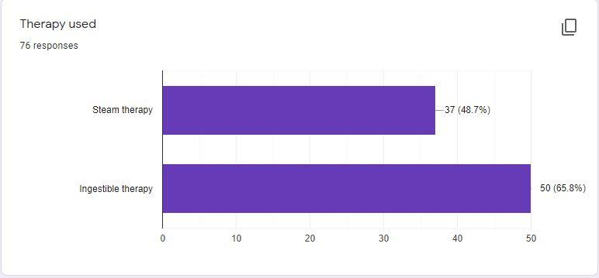

  - The majority of the respondents do not have a history of traveling to an area infected with COVID-19 but have had contact with those that travelled.

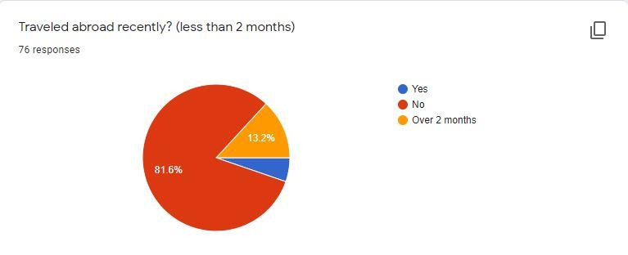

The online respondents cut across different educational backgrounds, gender and age groups.

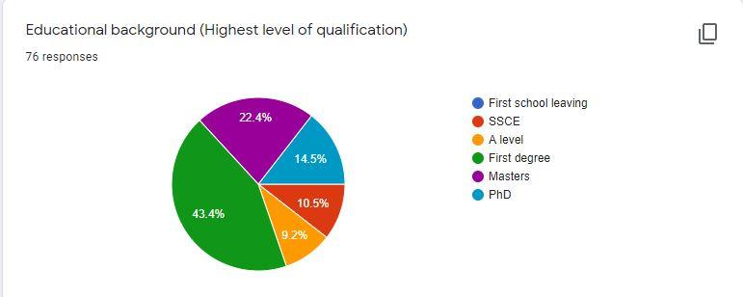

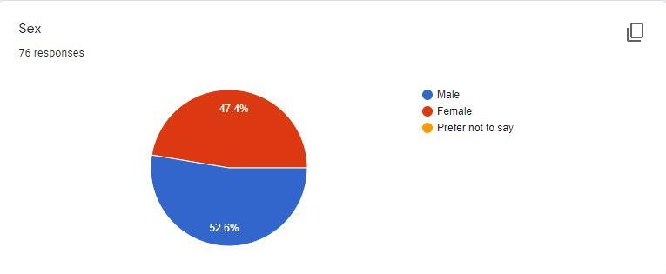

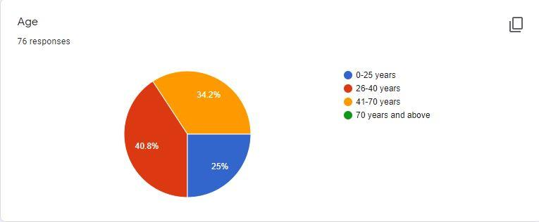

While the majority of respondents used these therapies to treat different symptoms of COVID-19, others used the therapies regularly as preventives.

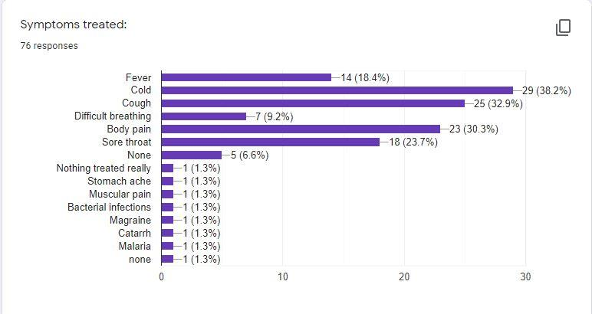

Recurrent combination of items used by respondents
- Drinking lemon, ginger and garlic in hot water.
- Vitamin C and fruits
- The Daily Detox Tea Mix is administered orally (that is, drinking it hot)
- Orange peels, garlic, ginger & onions boiled in water.
- Garlic, lemon, ginger, green tea, moringa, hot water
- Orange peel, ginger, onions, garlic, lemon
- Turmeric, garlic, onions, ginger, orange, lemon rind, Neem leaves
- Neem leaves, lemon, ginger and garlic
- Lemon grass, aloe vera, ginger
- Lemon grass, moringa seed, scent leaf, ginseng and soda water
- Salt and warm water solution
- Orange peels, garlic, ginger & onions boiled in water.

All the respondents reported that they recovered from the symptoms that they treated. Two side effects were mentioned:
- Sleeping
- Excessive bowel movements.

These therapies were used for 1-7 days. 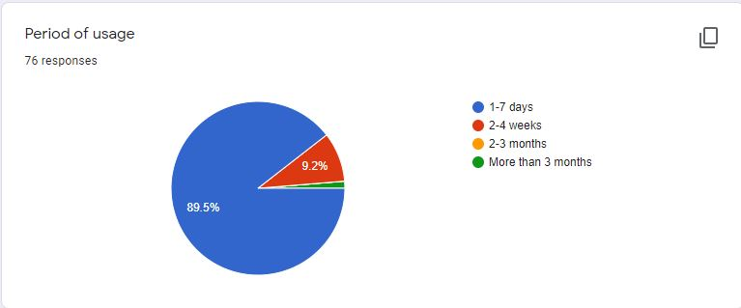

Discussion
Findings indicate that Nigerians are using alternative methods to respond to COVID-19. Responses also show that there are no significant side effects to either of the therapies and the majority of respondents recover from the symptoms within seven days. The elements/ingredients for both therapies are all well-known and available in the market across the nation. There is evidence that alternative methods are effective, safe and economical.

Recommendations
Nigerians should consult approved and certified alternative practitioners for advise on handling the symptoms of COVID-19.
The Federal and State Governments should look into the use of alternative remedies for the immediate response to COVID-19, both as preventives and for treating Nigerians who are in the isolation centres.

